Human Resource Management (HRM) System Documentation

- Overview

This document provides an overview and documentation for the HRM (Human Resource Management) system project. It includes information on the system architecture, database schema, and other relevant details. The key functionalities:

- Basic Management:
- Basic Configuration: Business unit, Department, Designation and Employment type configurations are possible.
- Employee Management:
- Creation and Updates: Allows creating and updating employee information.
- Retrieval: Retrieves employee details when needed with relevant filters and search mechanisms.
- Payroll Management:
- Payroll Elements: Manages various payroll components (e.g., basic salary, allowances, deductions).
- Payroll Policies: Defines rules for calculating salaries.
- Payroll Groups: Organizes employees into groups for payroll processing.
- Salary Management:
- Salary Assignment and Generation: Assigns salaries based on policies and generates payroll.
- Additions and Deductions: Handles additional payments (e.g., bonuses) and deductions (e.g., taxes).
- Employee Transfers and Promotions:
- Transfer and Promotion Generate: Generates employee transfers and promotions.
- Transfer and Promotion Records: Keeps records of employee transfers between departments and promotions between designations.
- Bonus Management:
- Bonus Policies: Sets policies for bonus distribution.
- Bonus Generation: Generates bonuses based on criteria.
- Business Unit Variations:
- These functionalities vary across different business units within the organization.
- Validations & Error Handling:
- Proper entity and policy validations and all kinds or error handling are maintained.
- System Architecture

  - Layered Architecture
- Presentation Layer (Controllers): Handles HTTP requests and communicates with the services via interfaces.
- Service Layer (Interfaces and Services): Contains business logic and communicates with the data access layer.
- Data Access Layer (Entity Framework, Model, DTO): Interacts with the database.

  - Interface and Dependency Injection
- Interfaces: Interfaces allow loose coupling between controllers and services. Controllers depend on abstractions (interfaces) rather than concrete implementations.
- Dependency Injection: This enables injection of services into controllers via constructor injection. This promotes testability and flexibility.

- Database Schema

  - Entity Diagram
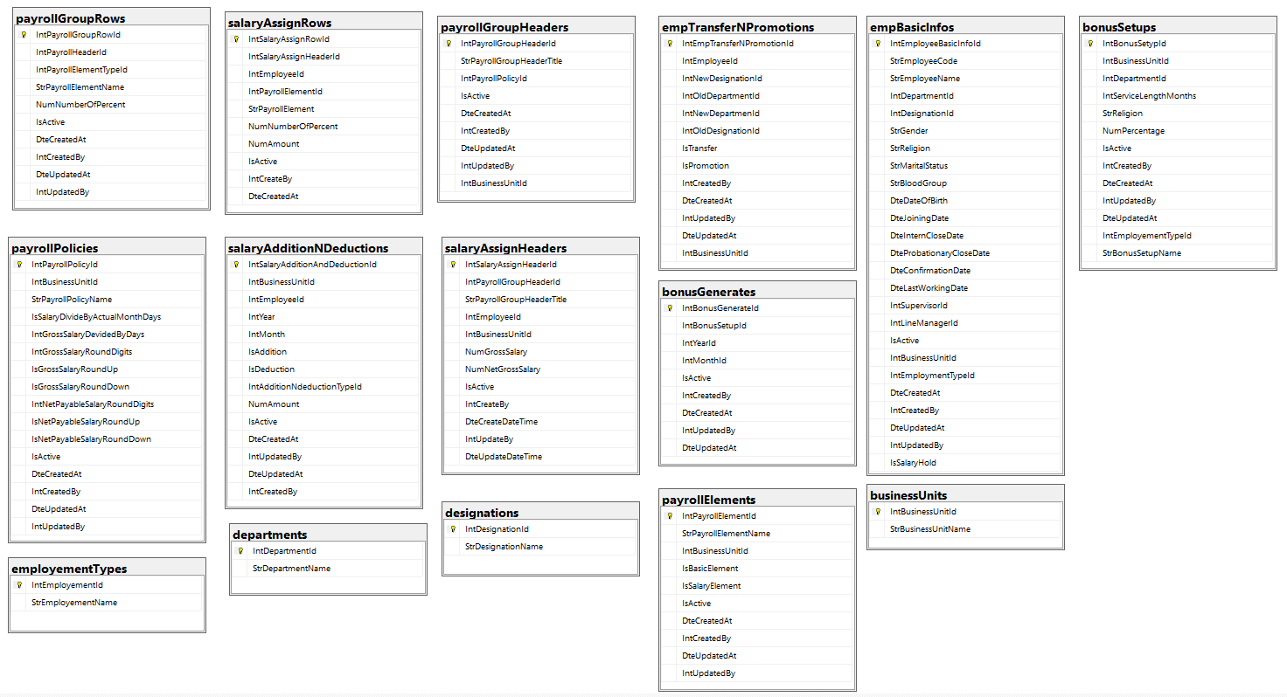
  - Entity Framework Code-First Approach
- Entities (Models): The entities (classes) representing database tables – BusinessUnit, Department, Designation, EmpBasicInfo, EmployementType, EmpTransferNPromotion, PayrollElement, PayrollGroupHeader, PayrollGroupRow, PayrollPolicy, SalaryAdditionNDeduction, SalaryAssignHeader, SalaryAssignRow, BonusGenerate, BonusSetup.
- DbContext: HRMContext class manages interactions with the database.

- Conclusion
This documentation provides an overview of the system architecture, including components such as controllers, services, data access layer, and models. It also outlines the usage of interfaces for communication between the controller and service layers, enhancing modularity and maintainability. Additionally, the documentation describes the database schema used by the HRM system.

